

**2015S2-DM2124-PRODUCTION AND PROJECT MANAGEMENT**

**Assignment 02**

**Done By:** Sri Sham Haran S/O R. Raja (155129R)

**Lecturer/Tutor-In-charge:**

Mr. Chris Hong

Mr. Quah Poh Yong

**Assignment 2 (part 1): Project Management Plan**

Admission No: 155129R

Name: Sri Sham Haran S/O R Raja

# Project Overview

## Title

Agent vs. Agent

## Overview of the project

* + Develop Agent vs. Agent to be released for iOS and Android devices. Agent vs. Agent is a 3D real time multiplayer game, bomb game. Players play as agents trying to bomb each other and try to win. Bombing safes will allow the player to gain a power-up that will aid them in the game.
  + Agent vs. Agent to be developed, tested and published within 8 months
  + Targeted to be in Top 200 in US Charts on Google Playstore and iOS App Store.
  + Target to (10 -18 Year Olds)
  + Achieve a unique game whilst innovating from existing concepts. Provide a different gaming experience to target audience.

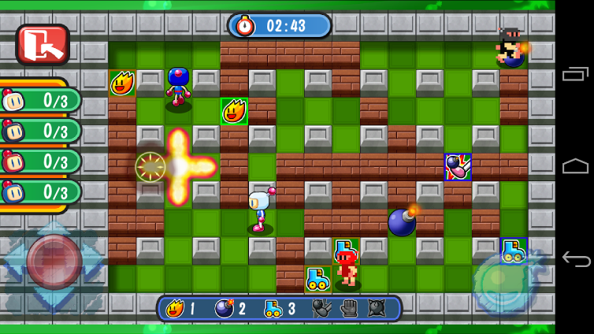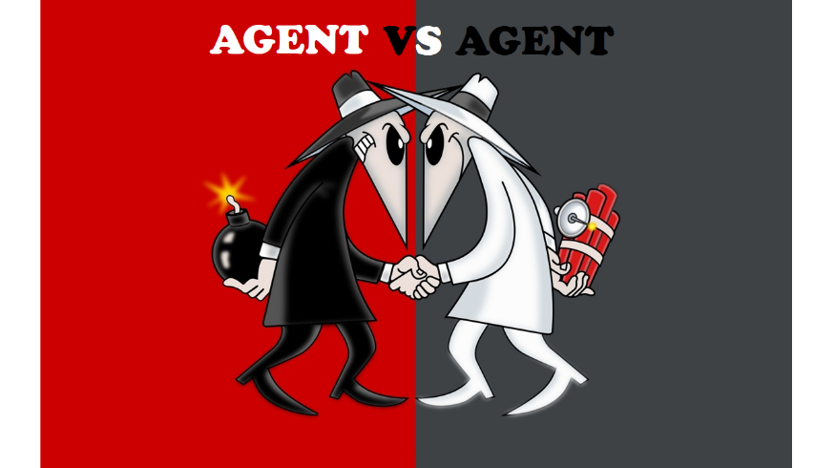

# Team

## Team structure

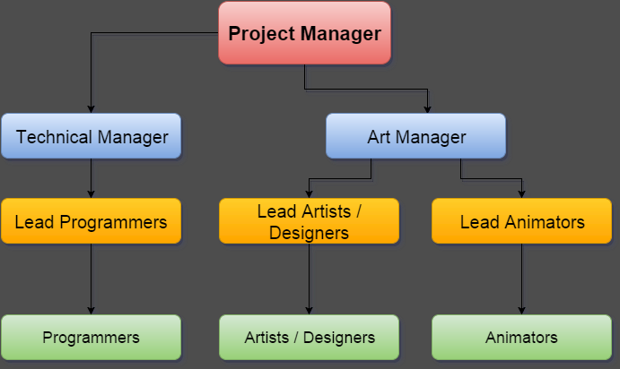

|  |  |
| --- | --- |
| **Role** | **Quantity** |
| Project Manager | 1 |
| Technical Manager | 1 |
| Art Manager | 1 |
| Lead Programmers | 1 |
| Lead Artists/Designers | 1 |
| Lead Animators | 1 |
| Programmers | 2 |
| Artists / Designers | 1 |
| Animators | 1 |

Some animation tasks will be outsourced due to lack of animators.

* Project Manager – Oversees project and ensures team adheres to timeline and meets objectives. Convey information from Product owner and stakeholders to team and vice-versa.
* Technical Manager – Oversees team of programmers and ensures programmers are following timeline. Does programming along with programmers. Works closely with Project Manager and Lead Programmer
* Art Manager – Oversees team of Artists & Designers as well as Animators and ensures artists, designers and animators are following timeline. Produces and edits art assets with artists. Works closely with Project Manager and Lead Artist & Designer and Lead Animator.
* Lead Programmer – Distributes programming tasks amongst programming team. Sets direction and requirements in regards to programming tasks. Works closely with Technical Manager.
* Lead Artist/Designer – Distributes art & design tasks amongst art & design team. Sets direction and requirements in regards to art & design tasks. Works closely with Art Manager
* Lead Animator – Distributes animation tasks amongst animation team. Sets direction and requirements in regards to animation tasks. Works closely with Art Manager.
* Programmers – Focuses on doing programming tasks. Works closely with Lead Programmer.
* Artists/Designers – Focuses on doing art & design tasks. Works closely with Lead Artist/Designer.
* Animators – Focuses on doing animation tasks. Works closely with Lead Animator.

## Team efficiency

The efficiency of the team will be maintained by encouraging the team to practice the following:

* + Effective Communication
  + Maintain a good understanding of the roles & responsibilities as well as the goal and objectives of the project.
  + Optimism and Commitment
  + Refrain from conflict or tension
  + Mutual Respect
  + Understanding the authority of each coworker

Challenges and risks:

* + Hard to relay change of scope(if any) to entire team
  + Possible deprivation of resources
  + Absence or lack of a properly detailed contingency plan
  + Not easy to check on outsource team and see if schedule and objectives are met

# System Preparation

* + Game Engine : Unity5
  + Modeling Software: Autodesk software(Maya, SoftImage, Motionbuilder)
  + Issue & Project Tracking : JIRA Software
  + Collaboration Programs: GitHub & SmartGit
  + Others: Photoshop, Illustrator, Visual Studio, Skype for Business,

Hardware:

* + Computer
  + iOS and android devices (for testing)

Possible Issues:

* + JIRA boards and may not be updated consistently
  + File collaborations are likely to face many conflicts that may require manual resolution
  + License will need to be purchased for Unity before launch

# Agile Management Plan

* + Agile Management Plan:
  + Establish Vision, goal and objectives.
  + Each iteration span will be 2 weeks long.
  + Sprint planning will occur at the start of each sprint where scrum team should establish what is required to be completed by the end of the iteration.
* Scrum daily meetings will occur where teams should establish what has been done and what needs to be done as well as clarify doubts and issues. This will help team prioritize objectives
* Scrum Review will occur nearing the end of each iteration where the team will review the sprint and change the project objectives such that it adapts to any issues that surface. Scrum team can demonstrate to stakeholders if possible.
  + Scrum retrospective meeting occurs at the end of each iteration where the team looks and what has been done and what needs to be done as well as change objectives or general team attitude. This should be used to optimize team efficiency.

Agile Team will consist of:

* + Development Team
    - Programmers, artists & animators that work on developing the game
  + Product Owner
    - Establish User stories and prioritizes backlog. This will allow the team to better prioritize the objectives that are to be met
  + Scrum Master
    - Organizes scrum and ensures the agile process goes smoothly
    - Changes each sprint
  + Stakeholder
    - People with interest in game that want to be updated on the progress of the game
  + Secretary role for Scrum
    - Record meeting minutes for each Scrum meeting

# Remarks

* *This part is optional for the assignment. If you want to make more note and details you can add any remarks here.*

Important notes:

* + Keep Stakeholders in mine during sprints and scrums
  + Refrain from having conflict with team members
  + Take discussions and scrums seriously
  + Update JIRA boards regularly and consistently
  + Everyone is to commit their work at the end of every working day
  + Try to avoid file collaboration conflicts
  + Try and keep to schedule and not fall behind

Team should stay positive and optimistic throughout the course of development.